

Dear Colleague,

This letter is to formally invite you to participate as a member of the drafting team of the SAON Road Map Task Force (RMTF), which is operating under the auspices of Goal 3 of the SAON Strategic Plan[1]. The purpose of your role on the RMTF drafting team is to develop a high-level definition, for the SAON *Road Map for Arctic Observing*. SAON has identified the development of this Road Map as essential to generating strong national investments in coordinated international Arctic observing, through confidently and coherently presenting the imperative observing foci, a strategy for observing them that leverages existing efforts and interests, supported by a value assessment of observing outputs towards societal benefit. The SAON *Road Map for Arctic Observing* definition should build upon national efforts and needs, existing Arctic road mapping activities, and ultimately serve as a guide for developing concrete national plans to support pan-Arctic observing needs.

It is envisioned that the RMTF drafting and review teams will deliver Phase I (see diagram) of the *Road Map for Arctic Observing* through developing a strong definition and high-level guidance for development. Under this guidance, SAON’s other committees (Committee on Observations and Networks (CON), Arctic Data Committee (ADC) will collaboratively build out the Roadmap from this definition through designing an assessment system built from as many existing resources (e.g. cyberinfrastructures, inventories) as possible; these sources will also be well-aligned with regional needs and global efforts. It is further envisioned that the *Road Map for Arctic Observing*, from the definition through design and development stage, will be informed by the principles on Indigenous Knowledge co-production.

The draft mandate for the RMTF drafting team reads:

On the basis of the document *Arctic Observing Summit - Observing System Implementation and Optimization Working Meeting[2]*

* Develop a high-level, structural definition for the SAON *Road Map for Arctic Observing* that will serve to generate strong international investments in Arctic observing
* Define how Arctic Societal Benefit Areas or other objectives should be used to shape the *Road Map for Arctic Observing*

The full mandate and recommendation are available at the SAON web site[3].

The Ask: You have been chosen as a member of the drafting team by the SAON Board based on your connection with a key activity, your experience with regional or global programs, or your connection to the principles of co-production of knowledge. We are asking you to engage in a short but intensive synthesis and writing process to produce a high-level definition for the SAON *Road Map for Arctic Observing* and to inform at the highest level what benefit areas or other objectives should be used to shape the Road Map. The RMTF includes a drafting team and review team that will work together on different schedules to produce the deliverable.

The Deliverable: We envision a document of no more than 2 pages as the final product of this process. It will address the points laid out above in the mandate and provide sufficient background and context to understand how these points were defined by the group and the context in which they should be applied.

Figure 1. Proposed strategy for undertaking the Road Map; dividing efforts across committees

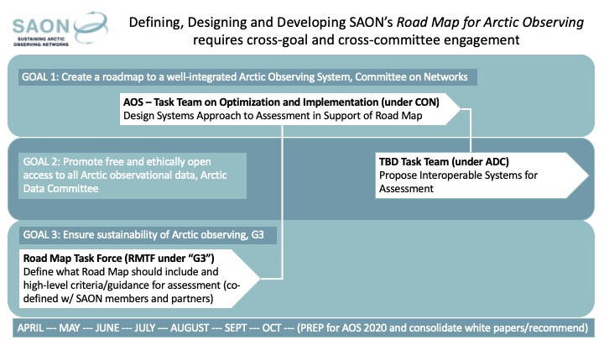

The Schedule: A proposed meeting schedule is outlined below (15-16 CET / 9-10 am EST).

|  |  |
| --- | --- |
| Date | Objective |
| 22th April | Introduction and review of mandate.  Introduction of participants  Identification of sources |
| 6th May | Drafting meeting |
| 20th May | Drafting meeting |
| 3rd June | Drafting meeting |
| 17th June | Drafting meeting |
| 2nd September | Approval of final draft version of document. Handover to review team for first review |
| 16th September | Update document. Handover to review team for second review |
| 30th September | Approval of final version of document |

On behalf of the SAON Board

Jan René Larsen   
SAON Secretary

Visiting: Hjalmar Johansens gate 14, 9007 Tromsø  
Postal: The Fram Centre, Box 6606 Langnes, 9296 Tromsø

Norway

Phone: +45 2361 8177  
E-mail: [jan.rene.larsen@amap.no](mailto:jan.rene.larsen@amap.no)  
Skype: jan_rene_larsen   
Internet: [www.arcticobserving.org](http://www.arcticobserving.org/)

1. https://www.arcticobserving.org/images/pdf/Strategy_and_Implementation/SAON_Strategy_2018-2028_version_16MAY2018.pdf
2. https://www.arcticobserving.org/images/pdf/Board_meetings/20190213/10_AOS_WG2_AGU_Meeting_Summary_v.02.04.2019.pdf
3. https://www.arcticobserving.org/images/pdf/Board_meetings/20190213/08_Recommendations_from_G3_to_Board_and_CON.docx