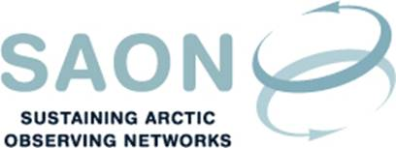

SAON Board meeting 25th August 2016
16-17 (CET) / 10-12 AM (EST)
Teleconference (GoToMeeting)

Draft agenda

- Introductions and adoption of agenda
- SAON External Review
  - The report from the External Review Committee will be presented by the chair, Helen C Joseph, HCJ Consulting.
[The report and the Executive Summary was circulated by email on 30th and 31st August]
  - Presentation at the SAO meeting
[David Balton, chair of the Senior Arctic Officials of the Arctic Council has asked for an update on SAON at the upcoming SAO meeting in Portland, USA, 4-6 October. Larry Hinzman will attend the meeting.]
- US SAON Office (Jeremy Mathis)
- White House Arctic Science Ministerial – SAON Brochure
[An updated version of the brochure will be prepared for the Ministerial. The Executive has prepared a draft text. There is a comment within the text on the use of the term ‘Indigenous knowledge’ versus ‘traditional and local knowledge’. A link to the existing brochure is found here: http://www.arcticobserving.org/images/pdf/Background/Final_Updated_SAON_Brochure.pdf]
- SAON work plan
[In an email from 30th August, Larry Hinzman asks the Board members to prioritise the recommendations from the External Review Committee]
- SAON Committees:
  - Arctic Data Committee (Peter Pulsifer)
  - Committee on Observations and Networks (Lisa Loseto)
- Arctic Observing Summit 2018
[Will be held with the ASSW in Switzerland from 15 - 27 June 2018]
- Next physical meeting; ASSW2017 in Praque (31 March - 7 April, http://www.assw2017.eu)
- Any Other Business
  - GEO-XIII Plenary, 7-10 November 2016

