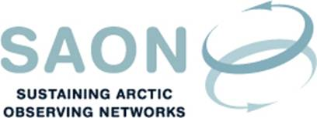

SAON Board meeting 21st December 2017
16-17 CET / 10-11 AM EST
Teleconference

Draft agenda

- Introductions and adoption of agenda
[Thorsteinn Gunnarsson]
- SAON Strategic Framework
[Minor changes have been introduced to the version from 30th November, and the document has been divided into ‘Strategy’ and ‘Implementation’.
Larry Hinzmann]
- GEO and SAON
[The Chairmanship has had a telephone conference with Barbary Ryan, GEO Secretariat Director. The proposal is to seek application as a GEO Initiative with the name ‘ArcticGEOSS’.
Barbara Ryan / Jan Rene Larsen]
- H2020 call: Copernicus evolution – Mission exploitation concepts / Monitoring of the Polar Regions, notably the Arctic, specifically for sea ice and environmental conditions
[David Arthurs]
- Any other business
  - Arctic Environment Ministers Meeting, 11-12 October, 2018, Rovaniemi, Finland
[SAON can submit a 2-pager through AMAP.
Jan Rene Larsen]
  - Invitation from Partnership for Observation of the Global Oceans (POGO) to attend the Annual Meeting, which will take place at Scripps Institution of Oceanography from 23 to 24 January 2018.
[Thorsteinn Gunnarsson]
- Next telephone conferences

