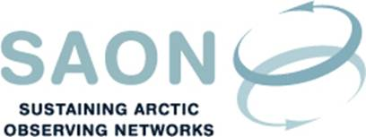

Meeting of Committee on Observations and Networks (CON)

17th October 2017 14-15 CET / 8-9 AM EST
Telephone conference
Draft agenda

Welcome to the call

SAON Strategic Framework development
[The Framework was developed during a workhop in Frascati in June. It is currently under review by the SAON Board; the Board will have a teleconference 30th October. Committee members are kindly asked to study ‘Goal 1’ in the document]

ToR and work plan for CON
[The Framework gives guidance to the Committee on its ToR and work plan. Further updates to these should probably await the finalisation of the Framework]

Contribution to Finnish Arctic Council Chairmanship: Value tree analysis with a focus on
[The project is a follow up to the 2016 Arctic Science Ministerial and the ‘International Arctic Observations Assessment Framework’ organised by STPI and SAON. The project has focus on meteorological and oceanographic cooperation, and is a Finland Arctic Council Chairmanship activity. Committee members are encouraged to identify project members and resources]

Arctic Circle
[Report from the break-out session ‘SCALES OF OBSERVATIONS – CONNECTING ARCTIC DATA, INFORMATION AND PEOPLE’, arranged by GEO, SAON, EPB, WMO, and ICC: http://www.arcticcircle.org/Media/09.29.17-arctic-circle-assembly-program.pdf]

Any other business
  - 2018 Arctic Observing Summit: http://www.arcticobservingsummit.org/http%3A//www.arcticobservingsummit.org/http%253A//www.arcticobservingsummit.org/aos-2018-davos-switzerland-0
  - 2018 Arctic Science Ministerial

https://www.arcticobserving.org/news/268-international-arctic-observations-assessment-framework-released

