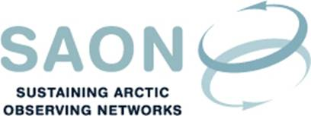

Meeting of Committee on Observations and Networks (CON)

11th September 16-17 CET / 10-11 AM EST
Telephone conference
Draft agenda

Welcome to the call
[Hannele Savela]

SAON CON interaction with G3 Task Force
[Sandy Starkweather]

SAON (CON) related breakout sessions and activities at Arctic Circle 2018
[Jan Rene Larsen]

Collaborations update (ADC, EU-PolarNet, GEO, GEOCRI)
[Jan Rene Larsen and Hannele Savela]

SAON G1 Implementation Plan and CON Work Plan (Status, update)
[Hannele Savela]

Arctic Science Ministerial, October 2018 (Update)
[Jan Rene Larsen]

Next meeting
[Tuesday 30th October 16 CET / 10 AM EST]

