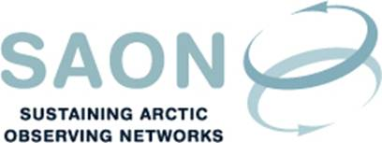

SAON Executive meeting 20th August 2018
16-17 CET / 11-12 AM EST
Teleconference

Draft agenda

- SAON Board meeting 12th September
- Committees
  - ADC:
    - Next meeting in Geneva in November
    - Arctic Mission System Study (AMSS). ESA project
  - CON, including interaction with G3 Task Force
- Arctic Observing Summit
  - Statements submitted for Arctic Science Ministerial
  - Follow up, including continuation of AOS WGs
- Arctic Science Ministerial 25-26 October
  - Side event(s)
  - Science Forum
- AMAP WG meeting in 25-27 September
- SAO meeting in 1-2 November
- Application as ArcticGEOSS

