A roadmap from coordination to implementation – Actions in support of sustained coordinated observations of Arctic change

White paper outline, v. 5 – 3 May 2019

Hajo Eicken, Sandy Starkweather, Henry W. Loescher, Raychelle Daniel, Peter Pulsifer, Matt Jones, Will Ambrose, Alice Bradley, Craig Lee

Motivation and key objectives

There is an urgent need for a cross-disciplinary Arctic observing system that tracks sub-seasonal to multidecadal change, advances understanding of poorly studied key aspects of transformational Arctic change, and informs predictions of and responses to rapid Arctic change across a range of scales and sectors. Both need and urgency have been articulated by a range of studies, assessments, and bodies from the local to international level; most recently these include the Arctic Observing Summits (AOS) (Murray et al. 2018; Lee et al., 2015; AOS Executive Organizing Committee 2018), the Second Arctic Science Ministerial (ASM-2), and in particular the Sustaining Arctic Observing Networks (SAON, https://www.arcticobserving.org) initiative of the Arctic Council (AC) and the International Arctic Science Committee (IASC). In the U.S. and at the international level, individual research collaboration efforts (Moore & Grebmeier 2018; Proshutinsky et al. 2009; Polyakov et al. 2017; Schuur & Abbott 2011; Uttal et al. 2016), bottom-up, community-driven programs such as the Study of Environmental Arctic Change (SEARCH; SEARCH Implementation Workshop Report; Lee et al. 2015; ADI 2012), and high-level assessments (National Research Council 2006) have been articulating the need for such an integrated observing system for a while. Recently, through the work of SAON, international bodies, and the AOS, several studies have been completed or are underway that provide frameworks to assess the societal and socio-economic benefits of sustained Arctic observations (STPI & SAON 2017; Dobricic et al. 2018; Strahlendorff et al., 2019).

As illustrated by a survey of sustained observations in marine and coastal environments, the disparity between different types of observations collected by a range of entities without much if any prior coordination or integration into a uniform data and information management framework presents a major hurdle towards integration of observing efforts (Eicken et al. 2016). SAON – represented at the national level by the U.S. Arctic Observing Network (USAON) office, with additional guidance from an Interagency Arctic Research Policy Committee (IARPC) Collaboration Team (CT) on Arctic observing, has developed a strategy (IARPC 2016) that lays out a collaborative pathway to overcome these challenges. Specifically, it has defined a roadmap process that identifies and puts into context observations, products, and services that are relevant to a so-called value tree that links specific observations to societal benefit areas (SBA) comprising the socio-economic and environmental social domains in which observing services, operations, and research provide societal benefit (STPI & SAON 2017).

Guided by the vision of decision-makers, planners, and the people of the Arctic having ready access to relevant and comprehensive data and information products needed in response to a rapidly changing Arctic, SAON has identified three goals: G1: Create a roadmap to a well-integrated Arctic Observing System; G2: Promote free and ethically open access to Arctic observational data; G3: Ensure sustainability of Arctic observing (Figure 1). This white paper outlines support actions at the national level that would address in particular the first two goals, help meet key objectives associated with these goals, and in the process bring about better links between the research community, a range of different Arctic observing data users, Arctic communities, and important international bodies and partners.

SAON has outlined the following objectives for goals 1 and 2:
G1-1: Conduct an inventory of national observational capacities;
G1-2: Complete an assessment of Arctic observational capacity;
G1-3: Provide recommendations for a roadmap for future Arctic observational capacities;
G1-4: Create opportunities to develop and implement observations in support of Arctic SBAs;
G1-5: Develop a long-term repository for relevant project deliverables.
G2-1: Create a road map outlining the steps towards achieving a system that will facilitate access to Arctic observational data;
G2-2: Advance a system to facilitate access to Arctic observational data;
G2-3: Establish a persistent consortium of organizations to oversee the development of a sustainable, world-wide system for access to all Arctic data.

While not complete and requiring additional input, G1-1 and G1-2 are being addressed by the SAON Committee on Observations and Networks (CON), while G2-1 has been taken up by SAON’s Arctic Data Committee (ADC). Here, we describe a series of networked activities that would build on and link to the work by SAON CON and ADC in attaining key aspects of the other goals, drawing on the U.S. research community and operational agencies and tying into and advancing international efforts. Specifically, the activities detailed below are a response to the SAON strategy, ASM-2, and the call to action from AOS 2018 and will result in
(i) an assessment of current capabilities, associated benefits, and major gaps (“knowledge map”),
(ii) development of a roadmap that clearly lays out a path towards an integrated Arctic observing system or system of systems, tying into local, national and global frameworks,
(iii) initiation of specific steps and implementation action that builds on (i) and (ii).
The networking activities we envision address these tasks with a focus on shared, cross-sector benefits (extending from research to policy and planning to strategy and tactics in responding to Arctic change), and the recognition that such an integrated Arctic observing system has to be designed around and through pre-existing observing activities, from research projects, agency-led programs at the national and international level, to community-based monitoring efforts.
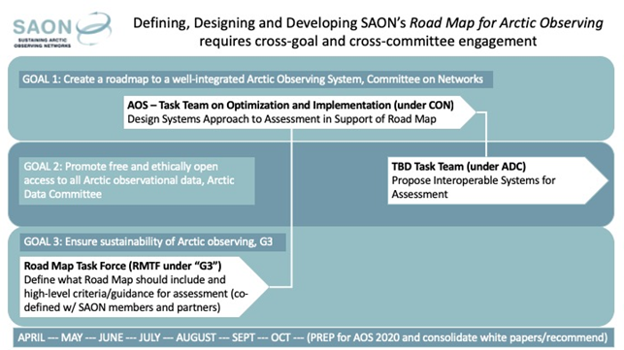Figure 1: Schematic of current SAON strategy and roadmap structure.

Approach

The objectives and tasks outlined above fall into three different categories and stages of a range of different networked activities that we summarily refer to as (i) coordination, (ii) design development, (iii) information infrastructure. This white paper outlines an approach that brings together different researchers, scientific bodies, data users, Arctic community representatives, and others to jointly step through a full cycle of activities starting with coordination of observing efforts, moving on to implementation with existing and new observing activities drawing from the coordination process, culminating in an element of practice that focuses on data and information product use as well as action based on observations (Figure 2). The latter two stages in turn inform further coordination and optimization of sustained observations. Taken as a whole, these internationally networked activities are meant to help transform dispersed, uncoordinated observations into an integrated observing system (or system of systems). We envision what is outlined here contributing to but not subsuming a formal long-term observing system implementation plan. The latter needs to be commissioned by SAON and an alliance of funding bodies, as outlined in SAON G3. By focusing design development and information infrastructure on the theme of food security in coastal and marine environments of the Pacific Arctic sector, the work laid out here seeks to demonstrate how such a broader-scale observing system implementation effort can unfold.

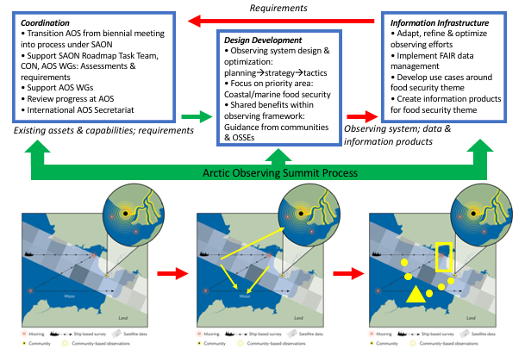
Figure 2: Schematic outline illustrating three core elements that link to three main objectives, with the AOS serving as a networking framework and mechanism to drive the process forward. The schematic maps shown at bottom illustrate how existing (black) and new (yellow) observations of essential variables (EV) in the Pacific Arctic sector would be optimized and linked by providing shared societal benefits through the lens of food security.

To help meet these broader objectives we propose to assemble task teams or working groups (where possible drawing on existing bodies as detailed in the Management Plan below) operating under SAON and its two extant committees (CON and ADC), and transforming the AOS from a biennial meeting into a sustained process that provides a framework for existing groups and new participants to jointly work towards a common goal. These different groups would support SAON by (a) helping complete the CON’s capabilities assessment (“knowledge map”) that identifies critical gaps, (b) producing an observing roadmap towards an integrated observing system of systems, and (c) facilitating design development of specific observing activities in high priority areas identified under (a) and (b) with a focus on food security in the Pacific Arctic sector.

Here, we wish to bring together stakeholders to scope an Arctic Observing System and help implement a key element that will focus on a combination of two different themes; (i) food security, and (ii) near-coastal and offshore marine processes. Our aim is to achieve this through various engagement activities, and to integrate existing capabilities and augment the design with new attributes (yet to be defined). If the task at hand was to craft a new Arctic Observing System from scratch, the development process would be slightly different from integrating existing capabilities. If scoping a new complex, system (such as those needed for an NSF Major Facility), stakeholders are brought together, societal impact and grand challenges crafted, and requirements captured. In this case, we are starting with many diverse interests including local communities, research activities and disciplines, Arctic organizations, and a myriad of existing observing system studies, planning documents and position papers (Chabbi and Loescher 2017). For each theme, we will synthesize this legacy information into a baseline understanding that can be used to inform and prime the proposed networking activities, and in turn, used to capture requirements and observing system design attributes.

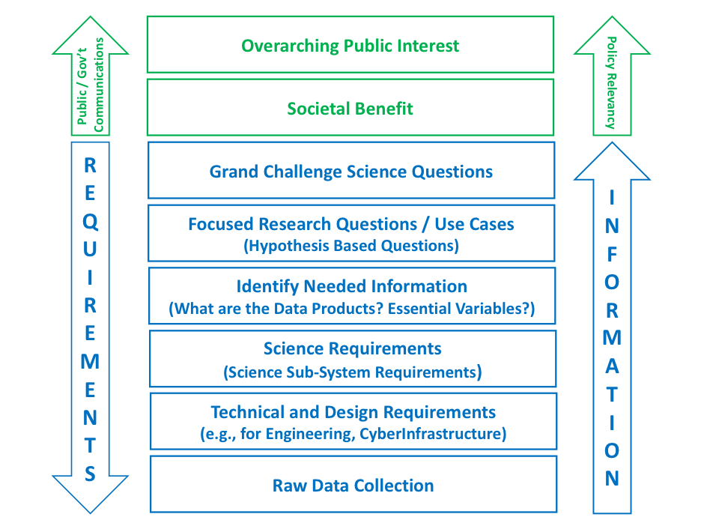
As part of the proposed activities, we will apply system engineering approaches to distill grand challenge questions, hypotheses, and societal benefit into tiered requirements and accounting for its inherent complexity at the inception of the development process (Figure 3, Loescher et al. 2017, Kossiakoff et al. 2011, Shishko 1995). Systematic capture of requirements explicitly defines what is needed to meet both the scientific and societal needs, and provides a foundation for an explicit observing system design (incl. managing fidelity and scope, constraining budget and level of effort, identify build-out and operations schedules, and manage risk). Capture of requirements is not a static process, but iterative with reviews and vetting processes to assure the needs of the broadest range possible of stakeholders are met. It encompasses the tools by which budget, risk, schedule, can be assessed in trade-off analyses, that result in an optimized design solution.

Figure 3. A simplified view of the system engineering approach to distill Grand Challenges and hypotheses into tiered requirements, and conversely, how the flow of information can be used to address the Grand Challenge or thematic questions.

Requirements flow from high-level, aspirational Grand Challenges, to more detailed science and design requirements. All of which must also meet societal benefit and public interest. In other words, societal benefits have a hierarchical, overarching association with Grand Challenge questions (modified from Loescher et al. 2017).

Secondary benefits of a requirement-based approach are: (i) serving as a way to find common ground among different stakeholders, users and observation and data provider groups, (ii) cost savings by applying a focused approach a priori, and not continually changing scope before it is realized, (iii) a precise way to communicate what is the observing system design and process among all stakeholders, sponsors, and the public, and (iv) as an a priori, provide the programmatic mechanisms to accommodate future change in design or scope. This approach has been used successfully for other large-scale science infrastructures (e.g., ocean research vessels, telescopes, gravitational interferometers, muon and neutrino detectors), but is still quite nascent in the environmental and social sciences.

To help link extant and newly implemented observing efforts into a coordinated, collaborative framework that provides shared societal benefits to different data providers and users, we propose to draw on the essential variables (EV) concept as defined by the Global Ocean Observing System (GOOS). As detailed by Lindstrom et al. (2012), identification of EVs associated with different societal benefit areas and operational applications can help provide observing requirements. These requirements in turn guide how observations are carried out (sensor type, location, sampling rate, etc.) and provide a link to existing or needed observing platforms and sensor systems. In moving from coordination of observations to design development to information infrastructure (Figure 2 and 4), the EV concept is a powerful focal mechanism that can help bridge different knowledge systems, applications, or observing approaches. Here, we suggest that development of a suite of EVs along with specific requirements and guidance on observing tactics for the theme of food security in coastal and marine environments can help illustrate how to overcome broader challenges.

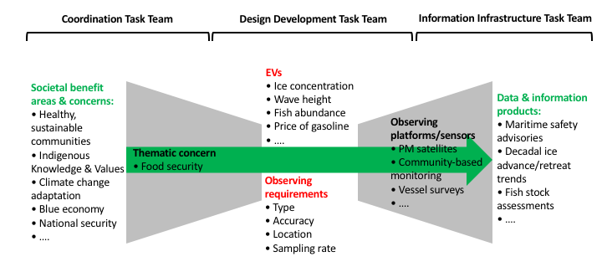
Figure 4: Schematic illustrating how the three different task teams will facilitate observing coordination and design development process all the way through data and information product generation, building on the EV concept.

(i) Coordination

SAON has developed into a critical international coordination interface for Arctic observing since the period of the International Polar Year (IPY, 2007-2009). It has been recognized since the most recent SAON review (SAON 2016), and underscored with calls to action since the first ASM, that SAON is under-resourced to take on bolder coordination and planning efforts called for by the international research community (e.g., Fairbanks declaration, Murray et al. 2018). In 2018, SAON issued a strategic plan and implementation document (https://www.arcticobserving.org/images/pdf/Strategy_and_Implementation/SAON_Implementation_Plan_version_17JUL2018_Status_approved.pdf) to guide its next decade of coordination activities, with an emphasis on concrete deliverables that could form the basis for responsive community proposals. Central to this plan is the development of a Roadmap for Arctic Observing (RAO) to optimize international investments around the most crucial observing foci.

The AOS, as a biennial, multi-track planning meeting and task of SAON, has emerged as the de-facto coordination forum for the broader community that is part of and relying on sustained Arctic observations. Hence, the AOS promises to be one of the critical mechanisms through which RAO planning can coalesce and progress, and SAON goals and objectives can be achieved. However, as recognized at AOS 2018 and follow-on workshops (Murray et al. 2018), capacity needs to be built at the international level to attain such goals, and provide a mechanism for the international observing and data user community to co-design and co-manage the nascent observing system. Below, we detail how this aim requires the transformation of the AOS from a meeting into a sustained engagement process under SAON that draws on task teams and working groups to executive specific tasks.

The AOS was established in 2012 as a SAON Task that fed into the SAON implementation process. AOS is a joint effort of the International Study of Arctic Change (ISAC), IASC, the Arctic Council’s Arctic Monitoring and Assessment Programme (AMAP), and an international scientific advisory committee that includes Indigenous expertise. The purpose of the AOS is to provide community-driven, science-based guidance for the design, implementation, coordination, and operation of a sustained long-term (decades) international network of Arctic observing systems. This AOS community platform to addresses the current and broadly recognized needs of Arctic observing across all science disciplines of the Arctic system, including the human dimension. The AOS fosters communication and international collaboration and coordination of long-term observations aimed at improving understanding of and response to system-scale arctic change. The AOS is an international forum for optimizing resource allocation, and minimizing gaps and duplication, through coordination of and exchange among researchers, government agencies, Indigenous and northern peoples, non-governmental organizations, the private sector and others involved or interested in long-term observing activities.

Since the inaugural Summit in 2013, the AOS has been established as a biennial gathering of hundreds of people from across all sectors invested in Arctic Observation that occurs in conjunction with Arctic Science Summit Week (ASSW). The AOS continues to be organized under the auspices of ISAC, IASC and AMAP and in partnership among an international group of scientific and Indigenous experts with committee members that provide additional focus on the themes of any given Summit. Past Summit outcomes include (here reference in particular the 2016 and 2018 statements and the influence on the ASM 2016 and 2018, and perhaps the activities of SAON and CON

Summit operational procedures are well-established, documented, and reflect broad consensus on the need for an independent scientific advisory committee that selects topics, format, and dissemination of results from each AOS event, as well as the timeline for activities leading up to each Summit and the process for and format of contributions (AOS Procedures 2018). With SAON and the AOS firmly established, and with the SAON strategy laying out a path for greater coordination of activities associated with sustained observations, the time is germane to fully integrate the AOS within SAON, but within a structure that allows for governance by a science-based committee that is independent of the SAON Board and formed according to the already established and well-working processes for the AOS. This transition would be implemented as part of the process and networking activities described here.

Organization, execution, and follow-up for each AOS make this a substantial undertaking. Since 2013 the International Arctic Research Center at the University of Alaska Fairbanks (IARC) and the Arctic Institute of North America (AINA, Calgary, Canada) and have informally supported a project office for the AOS with staff, resources and expertise. This has been further facilitated with contributions of staff time from SAON/AMAP and IASC and proposals funded by national funding agencies to support individual summits. Together, IARC and AINA are well-positioned to formally create a joint, international secretariat that can ensure continued success of the AOS, and support SAON objectives. As non-Arctic nations seek to find a meaningful way to contribute to the activities and objectives of the Arctic Council, one avenue could be through contribution to staffing the AOS Secretariat, perhaps through secondment of appropriate individuals for a 2-3 year period to AINA and IARC. Such conversations have begun with the Japanese Arctic Research Consortium (J-ARC) program office, in association with Japan and Iceland hosting ASM-3 in 2020. Such an approach would be cost-effective and would reinforce the necessary international collaborations required to continue to design and implement an integrated Arctic observing system.

The other aspect of seeing the AOS mature into a process is to create capacity to support key calls to action emerging from the summits. Such calls to action have been reviewed and refined in the context of the two ASMs held to date. While key achievements, such as the reports focusing on societal and economic benefits of sustained observations (STPI & SAON 2017; Dobricic et al. 2018; Strahlendorff et al. 2019) and case studies for selected Arctic challenges that have shown positive return on investment (AOS Executive Committee 2018) are outcomes of AOS calls to action taken up by the ASM, many other specific actions, in particular those requiring collaboration with the research community and Indigenous Peoples organizations have languished due to lack of resources. In particular, AOS 2018 participants recognized that
• Arctic observations rely heavily on research projects, rather than operational infrastructures, requiring coordination and subsequent shift of key observing system components, including community-based observations, to sustained, operational infrastructure support. The latter needs to target key variables that capture the Arctic system’s main features, augmented by research type observations to address topical problems.
• A properly resourced, comprehensive effort is needed to identify strengths and gaps in the current set of systems, sensors, networks, and surveys used to observe the Arctic. A knowledge map connecting these observations to societal benefits can then guide new observations, data management needs, and development of products and services, leading to a much-needed roadmap for Arctic system observing. Support for an international and local team of experts to complete these tasks under the auspices of SAON will greatly increase the benefits derived from Arctic observing activities and is deemed critical for successful deployment and sustained operation of an Arctic Observing System.
• Observing and data systems, at different spatial and temporal scales, have to emerge from co-design, co-production, and co-management processes with relevant stakeholders and rights-holders embracing free, ethical, and open data sharing, adhering to the “FAIR” data principles (Findable, Accessible, Interoperable, Reusable).
• To build an Arctic Observing System that is comprehensive, coordinated, sustainable, and fills current observational gaps, all existing assets and activities, including Indigenous knowledge, must be leveraged to the greatest extent. Such a system needs to span the full range of spatial and temporal observation scales. This is achievable by combining multiple observational methods and technologies, including Indigenous knowledge, community-based monitoring and citizen science, and by linking all relevant data systems.

The management plan below (incl. Table 1) provides further details on the task teams, working groups, and networking activities that will achieve coordination outcomes. how coordination will be achieved.

(ii) Design Development

The Design Development Task Team will bring together the observing systems design and engineering perspective outlined above (Figure 3), quantitative observing system design approaches (Lee et al., 2019, in review), and the Arctic Indigenous People”s and coastal communities” perspective on food security and marine ecosystems.

[Note: This section still requires work to merge and refine with subsequent text.]

• Research has shown that climate change and its attendant environmental impacts are adversely affecting food security in the Arctic. Changes such as increased warming are altering traditional food gathering grounds, making subsistence resources less accessible and in some instances, scarce. These changes are also altering habitats for subsistence resources and introducing hitherto unknown pollutants (Brinkman et al. 2016, Berner et al. 2016). One of the most substantial ecosystem changes has been observed in Arctic marine benthos, with far-reaching implications for the entire Arctic landscape (Kortsch et al. 2012).

(Inuit Circumpolar Council-Alaska 2015)
• The concept of food security within the Inuit worldview transcends availability; it refers to the ability to preserve traditional food systems in a way that nourishes and sustains the values that define and shape cultural identity.
• Traditional foods are essential not just for providing nutritional sustenance and ensuring physical health, but for psychological wellbeing as well.
• Unique attributes of the Arctic result in different food security challenges; Climate change a factor, but so are costs involved in hunting/gathering marine resources; Arctic food security impacted by the environment
• Six dimensions of Alaskan Inuit food security: 1) Availability, 2) Inuit Culture, 3) Decision-Making Power and Management, 4) Health and Wellness, 5) Stability, 6) Accessibility.
• Fifty-eight drivers of food insecurity identified: 37 drivers are linked to food security; 11 drivers are linked to food (in)security; and 10 drivers are linked to either food security or food (in)security

Recommendations for Action (Inuit Circumpolar Council-Alaska 2015)
• Develop and preserve equal partnerships between Alaskan Inuit experts and external entities.
• Generate baseline data and methodologies through Indigenous knowledge and scientific baseline data collection
• Develop a robust community-based research strategy based on IK principles, including protocols and monitoring activities.
• Incorporate IK into the formal education system and engage Elders to provide instruction
• Provide adequate support for cultural celebrations/programs that highlight traditional values.
• Draw on co-management experiences in other Inuit countries to identify best strategies for addressing the needs of Alaska’s Inuit.

Role of community-based environmental monitoring in improving Arctic food security
• Data from continuous environmental monitoring needed for greater understanding of the nature, extent and impacts of ecological changes in order to inform planning
• Data needed from local community-based monitoring as well as regional and international programs, representing observations from IK holders, practitioners and scientists.
• Requires strong cross-cultural and interdisciplinary partnerships
• Need to a) ascertain whether existing multi-level monitoring programs can provide required information, and establish or enhance linkages where needed, and b) develop new monitoring programs if need be.

(iii) Consolidated Information Infrastructure:

Data are an integral element of the observing system value network. Without a data system that makes well documented data accessible and usable, many kinds of observations are ephemeral and their value is limited. As part of this process, we will ensure that the overarching observing framework will emphasize data integrity throughout the entire process from data collection and management over time to different data uses including but not limited to science, policy development, and decision-making at all scales.

The broader research data community is increasingly referring to FAIR data principles (Findable Accessible Interoperable and Reusable). Findable includes the need to ensure that data are described with rich metadata, and indexed in a searchable resource such as a data catalogue. Accessible refers to a system where metadata and data are retrievable using standardized, open, free, and universally implementable sharing protocols, recognizing that access to some data resources be limited (i.e. the concept of ethically open data). Interoperable generally refers to the ability of digital information systems to exchange and make use of information and is typically implemented through the use of standardized data services. This is enhanced through the use of formally documented language and knowledge representation models (e.g., metadata, controlled vocabularies, formal ontologies). Reusable implies that users can interpret data and evaluate if a data resource is “fit for use” through rich, broadly usable descriptions and attributes, clear licensing, documentation of the history (provenance) of the data, and adherence to community standards.

In recent years, the Polar Data Community has made significant progress in realizing systems that adhere to the FAIR principles. Building on progress during the International Polar Year 2007-09, the IASC-SAON Arctic Data Committee and its partners and member organizations have been working together under the community developed guidelines for practice (i.e. IASC 2013) that follow the FAIR principles. Following a series of successful workshops, as a deliverable to the Arctic Science Ministerial process and the AOS, the Community is moving forward to develop a detailed design for an international, interconnected Arctic data system, that leverages substantial existing resources and cyberinfrastructure and seamlessly contributes to and integrates with the broader global data system. Activities include, for example:
- Mapping the Arctic Data Ecosystem to expand understanding of the ecosystem (data resources, actors, flows) and inform design processes
- Significant enhancement of a system for federated search that supports “single window” data discovery
- Formation of a Semantics Working Group to enhance interoperability

The broader data community is a network of interrelated communities. In addition to those working to ensure that we have access to remote sensing data, for example, we have a growing group of people and organizations actively working to share Indigenous knowledge and information based on that knowledge. This community continues to grow and thrive, although additional investment is required, recognizing that investments in new development should complement investments already made in existing, effective projects. Moving forward requires a better understanding of how Indigenous worldviews, semantics, and concepts stored in information systems can be appropriately represented and shared. Indigenous peoples must be recognized in their rightful place to lead the process on how to engage with their Indigenous Knowledge. Together, Indigenous and non-indigenous, we must balance recognition of data and information sovereignty while co-producing information infrastructure with the broader community. Activities executed under the specific implementation plan outlined (i.e. Marine & Coastal Food Security) will make significant contributions in this regard.

The established community structures (e.g. ADC, ASM Deliverable, AOS) will provide the foundation for the information infrastructure component. The Information Infrasctructure Task Team will function as a Working Group of the Arctic Data Committee, leveraging the existing framework established under SAON and IASC and formally connected to the SAON CON. This structure will also leverage the existing network of partners and participating organizations currently working together to design and implement the aforementioned, globally connected Arctic data system (Figure 5).

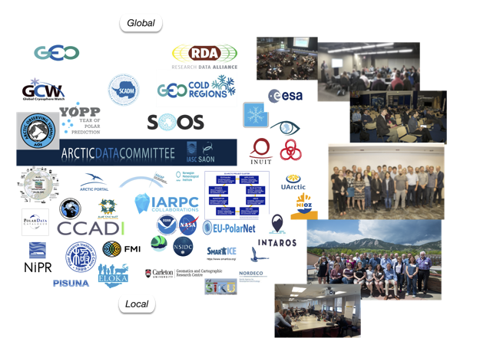
Figure 5. Organizations charged with coordinating data activities from local to global scale are increasingly working together to realize FAIR data principles. This system of data, people and organizations is an integral part of a Sustained Arctic Observing System.

At a national scale, contributions from the data community will be coordinated through the Interagency Arctic Research Policy Committee (IARPC) and its associated bodies including the Arctic Data Sub-Team, the Arctic Observing Systems Sub-Team, U.S. Arctic Observing Network program and others. These bodies bring together departments and agencies including NSF (i.e. NSF Arctic Data Center), NASA (including NSIDC, ORNL DAAC), NOAA and many others. Through the ADC and related activities, existing international partnerships will be leveraged, for example with the Global Cryosphere Watch, GEO Cold Regions Initiative, major regional projects such as INTAROS, as well as national initiatives such as the Canadian Consortium for Arctic Data Interoperability (CCADI), the National Institute for Polar Research (Japan) and many others. Local engagement is being achieved through Indigenous organizations (i.e. ICC), and existing projects such as the Exchange for Local Observations and Knowledge of the Arctic (ELOKA), INTAROS Work Package 4 and others.

This existing framework and network of data stewards will be leveraged to ensure that the observations and knowledge, in all forms, generated by a sustained, cross-disciplinary Arctic observing system will be available to a wide range of different users across generations.

Outcomes

(i) The AOS, so far largely a volunteer effort with significant capacity challenges, is restructured and anchored within SAON to serve a core support functions for the research community, Indigenous and community-based observing initiatives, agencies, the private sector and other entities with a stake in Arctic observing.
(ii) The AOS draws on the principles of co-production of knowledge as well as observing system co-design and co-management to advance internationally coordinated observing of a changing Arctic with a focus on shared societal benefits.
(iii) Implementation of an internationally coordinated suite of observations in the Pacific Arctic sector, centered around a set of essential variables, and the resulting information products meet key priorities and information needs of communities, Indigenous Peoples organizations, agencies, and the research community.
(iv) A pan-Arctic food-security oriented observing system information product emerges from the effort as a signature contribution to the global and Arctic GEOSS product portfolio.
(v) The SAON strategy and roadmap as well as the guidance emerging from the ASM, representing international consensus and priorities, are put in place through specific support action in this optimized framework, leading to greater coordination of sustained observations and planting the seeds for an integrated observing system of systems.
(vi) In summary, these products and outcomes prepare the ground for a (SAON-led) decadal scale implementation plan for an Arctic observing system of systems.
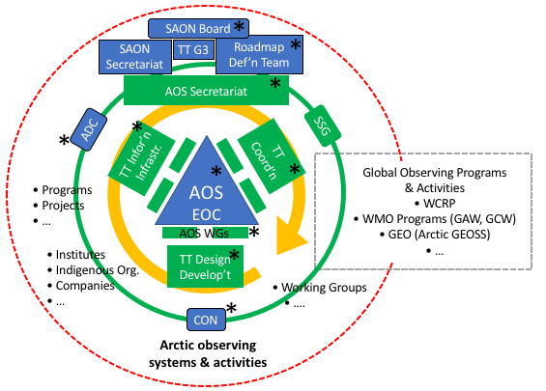
Figure 6: Schematic framework and management structure. Blue: Existing entities/activities; green: new entities/activities; orange: iterative coordination-design development-information infrastructure process outlined in text and detailed in Table 1 - Work Plan and Timeline.

Management Plan

Roles and Responsibilities of Network Leadership, International Partnerships, and SAON Steering Committee

The aim of the activities outlined here is to help focus a broader, largely uncoordinated range of observing activities and initiatives into a more structured approach, guided by the SAON Roadmap, specifically the Roadmap Definition Team, and established observing frameworks. By establishing and supporting a core set of task teams and working groups (shown in green in Figure 6), two key outcomes will be effected: (i) The AOS, so far largely a volunteer effort with significant capacity challenges, will be restructured and anchored within SAON to serve a core support functions for the research community, Indigenous and community-based observing initiatives, agencies, the private sector and other entities with a stake in Arctic observing. (ii) The SAON strategy and roadmap as well as the guidance emerging from the ASM, representing international consensus and priorities, will be implemented through specific support action in this optimized framework. The different SAON working groups and task teams provide a focal mechanism, while the AOS process provides a space and framework within which key aspects of coordination, design development, and information infrastructure can be parsed, evaluated, and refined. Rather than creating further, disconnected entities, the aim is to channel support actions into existing structures – specifically SAON in the Arctic and links to global efforts such as GEOSS (Figure 6) – to help build capacity and provide a nucleus for the coordinated implementation and optimization of an Arctic observing system of systems.

Specific roles and responsibilities of the network leadership, key entities and (inter)national partners, as well as others supporting the effort include:
(i) The core leadership team helping guide the activities outlined here consists of the co-authors of this white paper. Note, however, that the team’s involvement is mostly as members or leads of specific working groups, task teams etc, rather than a separate new body. The different roles that team members fulfil in the broader framework are indicated by asterisks in Figure 6, and are meant to promote cross-linkages and help ensure broader goals are met. Team members would co-lead with others the three Task Teams (Coordination, design development, information infrastructure) that provide much of the support action to SAON, help support and provide continuity to the AOS Working Groups which cover varying topics identified every two years through the AOS process.

(ii) The AOS Secretariat is described above and seen as providing the personnel and supporting resources to build up and maintain the AOS process and activities laid out by the SAON Road Map Definition Team (Figure 6). Initially, it would be led out of IARC by the Project Coordinator (see iii, below) and out of AINA by a staff member, with further support from key international partners anticipated over the course of next few years. The secretariat would translate guidance from the SAON Board and Committees into specific action, and support the various elements of the work plan outlined below.

(iii) A project coordinator would be serving a key role in providing (co)leadership of the AOS Secretariat, taking responsibility to coordinate the communication and collaboration process between the three Task Teams, and in particular facilitate the activities under these three task teams that lead from societal benefit areas to essential variables to specific observing activities and resulting data products (Figure 4).

(iv) SAON would serve an important role in management of the proposed activities through oversight of the Task Teams, with ADC, CON and the to-be-established SSG serving in this oversight role. The SAON Secretariat would interface with the AOS Secretariat, potentially sharing responsibilities as appropriate. The SAON Roadmap Definition Team would provide guidance to the coordination-design development-information infrastructure cycle and the associated program elements.

(v) A major element of building capacity in support of broader SAON and US AON goals is the entrainment and engagement of a range of different partners at the national and international level. Within the U.S., in addition to established research groups and other entities, the goal would be to entrain early-career researchers (including students), scientists/researchers from outside of the Arctic community, and non-experts in the Arctic community (i.e., communities and people in policy-advising roles). While each of these groups will have their own needs for this observing network, the framework of AOS Working Groups, Task Teams and SAON Committees provides different entry points for different levels of interest and engagement. The Food Security theme will help ensure relevance and utility of the activities to these different participants and constituents. Beyond these engagement efforts, close collaboration with organizations and groups active in the U.S. Arctic observing community will be critical. Key partners include the IARPC Observing and Environmental Intelligence Collaboration Teams (and other CTs as appropriate), the SEARCH program’s Arctic Observing Working Group, Inuit Circumpolar Council (ICC) Alaska, the National Center for Ecological Assessment and Synthesis (NCEAS) as a host of the information infrastructure element, the Arctic Observing Viewer (AOV) team and Alaska Ocean Observing System (AOOS) for geospatial analysis of observing assets and asset planning, the Alaska Climate Adaptation Science Center (CASC) as a way to link into tribal and federal agency information needs and data holdings. Importantly, large observing projects or initiatives with a footprint in the Pacific Arctic sector and links to marine and coastal food security, such as the Distributed Biological Observatory (DBO) or the Beaufort Gyre Observing System (BGOS), would be involved through AOS working group or task team membership and other mechanisms. We also envision a link to NSF’s Navigating the New Arctic (NNA) projects, specifically those with a food security or observing component, drawing on the annual NNA project meeting and the AOS as means to interface.

(vi) Key international partners include institutions contributing to and participating in the AOS Secretariat, specifically AINA in Canada in the near-term and others from Asia and Europe in the long-term. Beyond that, partnerships with national research institutes with a strong Arctic observing component, such as Alfred Wegener Institute (AWI) in Germany, National Institute for Polar Research (NIPR) in Japan, and others will help in the transition from coordination to design development and information infrastructure. Indigenous Peoples organizations and governing bodies as well as local and regional Arctic governments would be part of the food security thematic activities. Finally, international observing initiatives and programs play a key role in the SAON Road Map process and the AOS (see Figure 3). Two efforts, one currently underway, the European Union supported INTAROS project and an effort anticipated to ramp up in 2020, i.e., an Arctic node of the Global Earth Observing System of Systems (ArcticGEOSS) are of particular relevance, as are more broadly the Group on Earth Observations (GEO) and the Global Climate Observing System (GCOS) under the World Meteorological Organization (WMO). For the food security theme, the Pacific Arctic Group (PAG, organized under IASC) will serve as a facilitator of coordination of observations and data sets. Finally, to help engage with the private sector beyond the level of past AOS participation, establishing a working relationship with the Arctic Economic Council (AEC) will be important.

Work Plan and Timeline

Timeline/Phase | Activities | SAON Goals & international program links | Outcomes/Products
Summer 2019 to Spring 2020  (Coordination – Year 1) | • AOS governance transitioning into SAON  • AOS 2020 WGs underway (Design & Implementation, Data, CBM & Food Security, Private/Public Partnerships)  • AOS 2020: Key roadmap elements – review/refine assessment approach, implementation strategies for select themes, set detailed work plan for 2020-2022  • 3rd Polar Data Forum - Co-Convened by Arctic Data Committee, hosted by FMI | • SAON G3 - define road map (Fig. 1)  • SAON updates observing assessments  • AOS WGs contribute to roadmap, assessment (SAON G1), and interoperability approach (SAON G2)  • INTAROS – Complete assessment? | • Road map definition from SAON to guide C2I efforts  • Consolidated assessment framework for coordination & implementation  • Four WGs launched into roadmap efforts
Summer 2020 to Fall 2020  (Coordination & Design Development – Year 1 & 2) | • AOS WGs work on roadmap, assessments, prepare input to ASM-3  • WG Design & Implementation & WG CBM/Food Security: Assessment of Pacific Arctic Sector observing needs, assets, gaps  • WG Data: Design and first phase Implementation of semantically enabled “single window” (federated) search  • Other WGs: ??? | • Link to newly EU-funded Arctic GEOSS  • SAON/AOS Work meeting at ASM-3 to define & submit higher-level support needs (G3 Group at ASM-3)  • Work with PAG on Pacific Arctic assessment – identify links to food security | • Assessment for Pacific Arctic sector (broad)  • First draft roadmap components Pacific Arctic sector  • WG Data: First phase Implementation of semantically enabled “single window” (federated) search
Winter 2020 to Summer 2021  (Coordination & Design Development – Year 2) | • WG Design & Implementation & WG CBM/Food Security: Transition from assessment to coordination – prioritize new observations, optimize planned observations  • WG Data: Enhancing single window search. “Tune” search to ensure highest quality search results.  • WG Data: Enhancing single window search. “Tune” search to ensure highest quality search results.  ? Participate in assessment – workshop with ADC/NCEAS?  • Other WGs: ???  • Begin collaboration with Arctic GEOSS on outlining data product meeting Food Security observing/information needs | • SAON reviews draft roadmap – updates observing capacity assessments  • Work with DBO, PAG, and others on Food Security observing implementation  • Begin work with Arctic GEOSS | • Assessment for Pacific Arctic sector (broad & focus on Marine & Coastal Food Security)  • Complete draft roadmap components Pacific Arctic sector  • Enhanced single window search. “Tuned” for Marine & Coastal Food Security  • Enhanced access to data (from data services wherever possible) relevant Marine & Coastal Food Security
Fall 2021 to Spring 2022  (Design Development, information infrastructure, Coordination – Year 3) | • WG Design & Implementation & WG CBM/Food Security: Transition from assessment to coordination – prioritize new observations, optimize planned observations  • WG Data: Develop use case around Food Security theme  • Other WGs: ??? | • SAON convenes G3 group to build out funding structures | • Outline of Arctic GEOSS Food Security data/information product
Summer 2022 to Spring 2023  (Design Development, information infrastructure, Coordination – Year 3 & 4) | • AOS 2022: Review & refinement of assessments & roadmap; coordination & implementation mechanisms for Food Security theme  • Design Development: For Marine & Coastal Food Security draw on assessment to guide observations for 2022/23 season, incl. launch of new observations through partnering & internal resources  • Other WGs: ???  • ASM-4: Funding models, Mandate for decadal plan??? | • SAON facilitates funding model planning  • SAON initiates development of decadal observing plan | • Roadmap finalized  • First set of coordinated observations under new framework
Summer 2023 to spring 2024  (information infrastructure, Coordination, Design Development – Year 4 & 5) | • Data WG: Review and refine data and information product use & dissemination  • Design Development: 2nd season of Food Security component of observing system – expand to pan-Arctic  • Other WGs: ??? |  | • Marine & Coastal Food security GEOSS data product first draft
Summer 2024 to Spring 2025  (Coordination, Design Development & information infrastructure – Year 5) | • AOS 2024: Discussion/review of decadal plan, funding models  • ASM-5: Put decadal plan in place? |  | • Marine & Coastal Food security GEOSS data product final

Assessment of Activities and Networking

Given the number of individual elements that make up the organizational structure described here, assessment of the efficacy of the activities and networking would be important to help guide the overall process as well as steer specific action on the food security theme. An outside evaluation that ties into the AOS cycle during the middle of the work plan laid out in Table 1 will likely have the greatest impact on deliverables and outcomes.

References
[AOS EOC] Arctic Observing Summit Executive Organizing Committee. 2018. Report of the 4th Arctic Observing Summit: AOS 2018. Davos Switzerland, 24-26 June 2018: International Study of Arctic Change (ISAC) Program Office, Arctic Institute of North America, Calgary, Canada.
[AOS] Arctic Observing Summit Procedures. 2018. Terms of reference for the Sustaining Arctic Observing Networks Governance and Operations.
[ASM2] 2ndArctic Science Ministerial. 2019. Report of the 2nd Arctic Science Ministerial: Co-operation in Arctic science – challenges and joint actions Berlin, Germany: Arctic Science Ministerial.
Berner J, Brubaker M, Revitch B, Kreummel E, Tcheripanoff M, Bell J. 2016. Adaptation in Arctic circumpolar communities: Food and water security in a changing climate. International Journal of Circumpolar Health 75 (art. 33820).
Brinkman TJ, Hansen WD, Chapin FS, III, Kofinas G, BurnSilver S, Rupp TS. 2016. Arctic communities perceive climate impacts on access as a critical challenge to availability of subsistence resources. Climatic Change 139:413-427.
Chabbi A, Loescher HW. 2017. The Lack of Alignment among Environmental Research Infrastructures May Impede Scientific Opportunities. Challenges 8:18.
[ADI- AON] Design and Implementation Task Force, Arctic Observing Network. 2012. Designing, optimizing, and implementing an Arctic Observing Network (AON): A report by the AON Design and Implementation (ADI) Task Force. Fairbanks, Alaska: Study of Environmental Arctic Change.
Eicken H, Lee OA, Lovecraft AL. 2016. Evolving roles of observing systems and data co-management in Arctic Ocean governance. Pages 1-8. OCEANS 2016 MTS/IEEE Monterey: IEEE.
[IARPC] Interagency Arctic Research Policy Committee of the National Science and Technology Council. 2016. Arctic Research Plan FY2017-2021. Washington, DC: IARPC.
Anchorage, AK.
[IASC] International Arctic Science Committee. 2013. “Statement of Principles and Practices for Arctic Data Management.” Potsdam, Germany. http://www.iasc.info/images/pdf/IASC_data_statement.pdf.
[ICC-Alaska] Inuit Circumpolar Council-Alaska. 2015. Alaskan Inuit food security conceptual framework: How to assess the Arctic from an Inuit perspective. Technical Report.
Kortsch S, Primicerio R, Beuchel F, Renaud PE, Rodrigues J, Lønne OJ, Gulliksen B. 2012. Climate-driven regime shifts in Arctic marine benthos. Proceedings of the National Academy of Sciences 109:14052-14057.
Kossiakoff A, Sweet WN, Seymour SJ, Biemer SM. 2011. Systems engineering principles and practice. John Wiley & Sons, Inc.
Lee C, and 25 others. 2019, in revivion. A Framework for the Development, Design and Implementation of a Sustained Arctic Ocean Observing System. Frontiers in Marine Science – OceanObs19 Community White Paper.
Lee C, Eicken H, Jakobsson M. 2015. The Arctic Observing Summit 2013. Arctic 68.
Lee O, Eicken H, Kling G, Lee C. 2015. A framework for prioritization, design and coordination of Arctic long-term observing networks: A perspective from the US SEARCH Program. Arctic:76-88.
Loescher HW, Kelly EF, Lea R. 2017. National Ecological Observatory Network: Beginnings, Programmatic and Scientific Challenges, and Ecological Forecasting. Pages 51-76. Terrestrial Ecosystem Research Infrastructures, CRC Press.
Lindstrom E, Gunn J, Fischer A, McCurdy A, Glover L. 2012. A Framework for Ocean Observing. By the Task Team for an Integrated Framework for Sustained Ocean Observing.
McNeeley SM. 2012. Examining barriers and opportunities for sustainable adaptation to climate change in Interior Alaska. Climatic Change 111:835-857.
Moore SE, Grebmeier JM. 2018. The Distributed Biological Observatory: Linking physics to biology in the Pacific Arctic Region+ Supplementary File (See Article Tools). Arctic 71:1-7.
Murray MS, R.D S, Ibarguchi G. 2018. The Arctic Observing Summit, background and synthesis of outcomes 2013-2016.: International Study of Arctic Change (ISAC) Program Office, Arctic Institute of North America, Calgary, Canada.
[NRC] National Research Council Committee on Designing an Arctic Observing Network. 2006. Toward an integrated Arctic observing network. National Academies Press.
Polyakov IV, Pnyushkov AV, Alkire MB, Ashik IM, Baumann TM, Carmack EC, Goszczko I, Guthrie J, Ivanov VV, Kanzow T. 2017. Greater role for Atlantic inflows on sea-ice loss in the Eurasian Basin of the Arctic Ocean. Science 356:285-291.
Proshutinsky A, Krishfield R, Timmermans ML, Toole J, Carmack E, McLaughlin F, Williams WJ, Zimmermann S, Itoh M, Shimada K. 2009. Beaufort Gyre freshwater reservoir: State and variability from observations. Journal of Geophysical Research: Oceans 114.
Ready E. 2016. Challenges in the assessment of Inuit food security. Arctic 69:266-280.
Schuur E, Abbott B. 2011. Permafrost Carbon Network: High risk of permafrost thaw. Nature 480:32-33.
Shishko R, Aster R. 1995. NASA systems engineering handbook. NASA National Aeronautics and Space Administration Special Publication 6105.
Strahlendorff M, Veijola K, Gallo J, Vitale V, Hannele S, Smirnov A, Tanaka H, Sueyoshi T, Nitu R, Larsen JR. 2019. Value tree for physical atmosphere and ocean observations in the Arctic. Finnish Meteorological Institute. Report no. 9523360728.
[SAON] Sustaining Arctic Observing Networks. (https://www.arcticobserving.org)
---. 2016. SAON External review: Review report.
[US AON] United States Arctic Observing Network: https://www.iarpccollaborations.org/teams/Arctic-Observing-Systems
Uttal T, Starkweather S, Drummond JR, Vihma T, Makshtas AP, Darby LS, Burkhart JF, Cox CJ, Schmeisser LN, Haiden T. 2016. International Arctic systems for observing the atmosphere: An international polar year legacy consortium. Bulletin of the American Meteorological Society 97:1033-1056.
Walch A, Bersamin A, Loring P, Johnson R, Tholl M. 2018. A scoping review of traditional food security in Alaska

